Musanga identification from UAV imagery, first test on Yoko RGB UAV mosaic (2020)

Intro
The objective was to assess whether Musanga cecropioides, a pioneer tree species characteristic of secondary tropical forests, can be reliably identified from ultra-high-resolution RGB UAV orthomosaics using deep learning. To achieve this, manually digitized tree crowns were used to create a reference dataset in which Musanga crowns were labelled as positives and all other tree species as negatives. A lightweight U-Net semantic segmentation model with a ResNet-18 encoder was trained on image patches extracted from the orthomosaic and evaluated using independent validation and test datasets. Model performance was assessed at both the pixel and polygon (individual tree crown) levels using threshold optimization, ROC-AUC, precision-recall metrics, Dice/F1 scores, and visual inspection of prediction maps. Finally, the trained model was applied to the complete 1.03-billion-pixel orthomosaic to generate wall-to-wall probability and binary maps of Musanga occurrence across the study area.
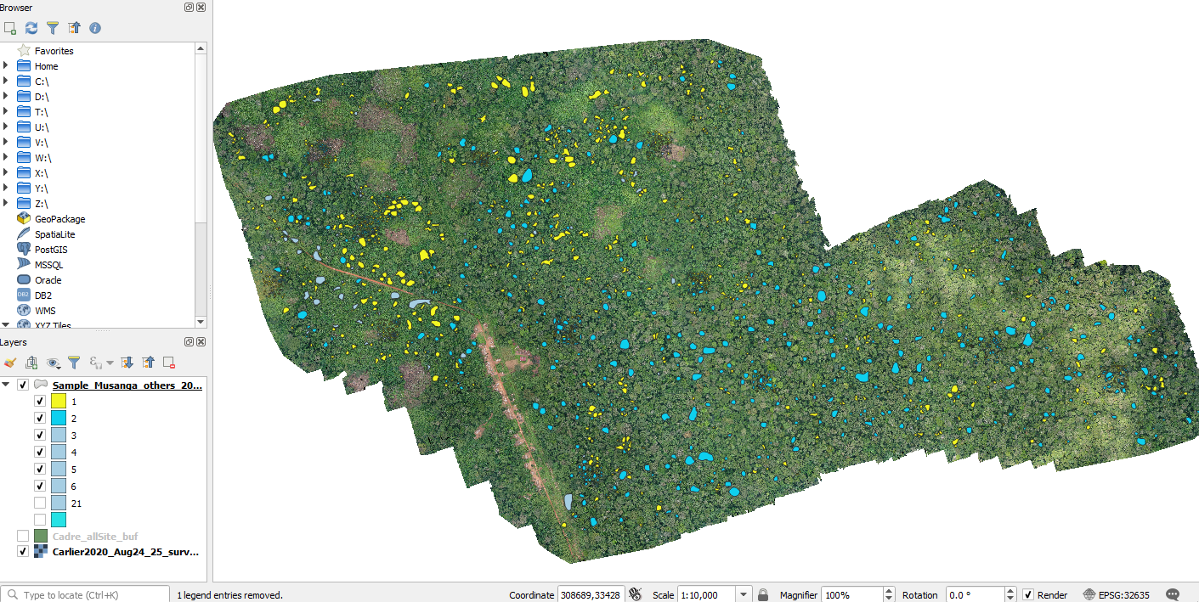
Figure 1: UAV Orthomosaic of the Yoko study area (2020), see table for details. The yellow polygons indicate the observed Musanga occurences (3042 crowns), green polygons indicate other trees (ie non-occurences) (2346 crowns).

Data
Table 1: summarizes the characteristics of the UAV orthomosaic and the deep-learning workflow used for Musanga detection. The study was based on a single ultra-high-resolution RGB orthomosaic comprising more than one billion pixels, which was processed using a U-Net semantic segmentation model with a ResNet-18 encoder and a patch-based inference strategy.
Metric | Value
Orthomosaic size | 44,359 × 23,217 pixels
Model | U-Net (ResNet-18)
Total reference crowns | 5,388
Musanga crowns | 3,042
Non-Musanga crowns | 2,346

Table2: summarizes the manually digitized reference dataset used for model development and independent evaluation. In total, 5,388 tree crowns were delineated, including 3,042 Musanga and 2,346 non-Musanga trees. The dataset was divided into training, validation, and test subsets, enabling threshold selection and performance assessment on independent observations.
Dataset | Musanga | Other trees | Total
Training | 1,021 | 567 | 1,588
Validation | 924 | 664 | 1,588
Test | 1,097 | 1,115 | 2,212
Total | 3,042 | 2,346 | 5,388

Methodology
The workflow consisted of six main steps (Figure 2). First, an ultra-high-resolution UAV RGB orthomosaic and manually digitized tree crowns were used to construct a reference dataset distinguishing Musanga from all other tree species. Image patches of 512 × 512 pixels were extracted and used to train a U-Net semantic segmentation model with a ResNet-18 encoder initialized with ImageNet weights. Model performance was evaluated on independent validation and test datasets at both the pixel and polygon (tree crown) levels, and an optimal decision threshold was selected using validation data. Finally, the trained model was applied to the complete orthomosaic (>1 billion pixels) to produce wall-to-wall probability and binary maps of Musanga occurrence across the study area.
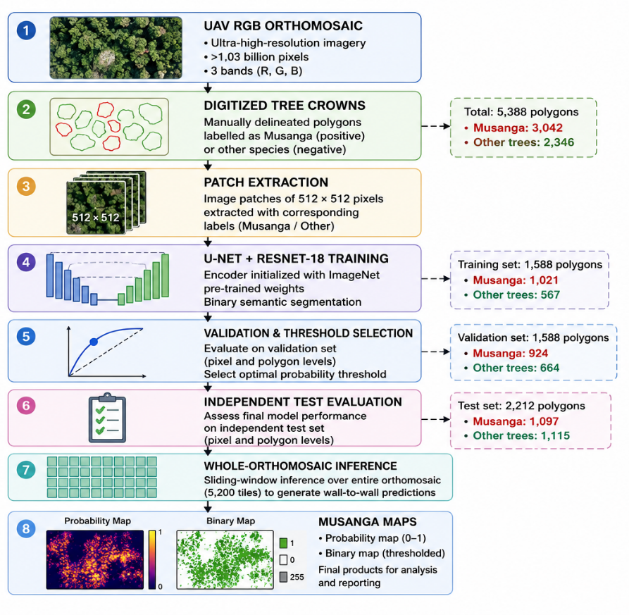

Results
Validation performance of the U-Net (ResNet-18) model across a range of probability thresholds. Precision, recall, specificity, Dice score, and balanced accuracy were computed using the independent validation dataset comprising manually delineated Musanga and non-Musanga tree crowns. The model exhibits excellent discrimination across thresholds, with specificity remaining above 0.95 and precision approaching 1.0 for thresholds greater than approximately 0.02. Recall decreases progressively as the threshold increases, illustrating the expected trade-off between omission and commission errors. The optimal pixel-level threshold selected for subsequent analyses was 0.008 (dashed blue line), corresponding to a region of high Dice score (~0.94) and balanced accuracy (~0.94), while maintaining both high sensitivity and specificity. These results indicate that the model produces conservative probability estimates, requiring a relatively low decision threshold to maximize agreement with the reference data.

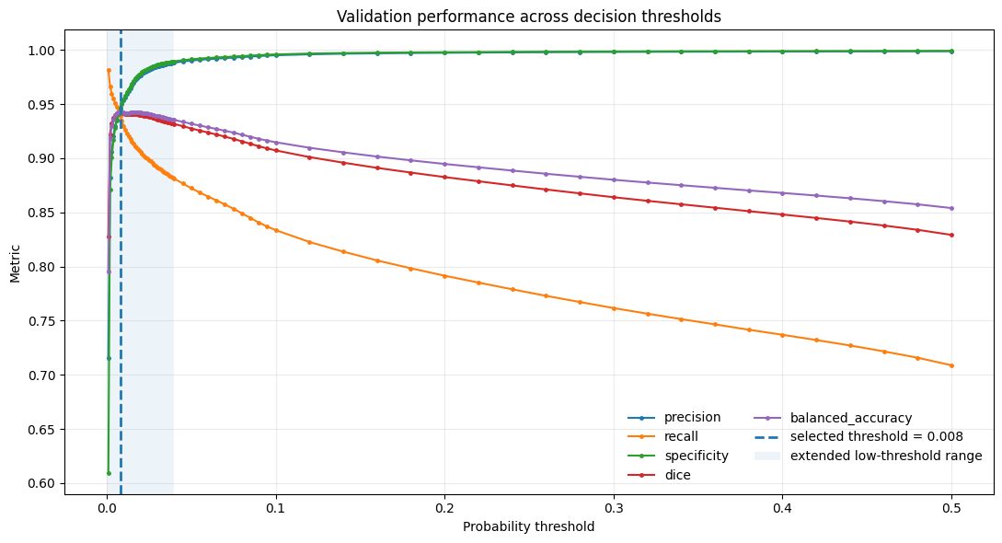

Distribution of predicted probabilities for Musanga and non-Musanga tree pixels in the independent test dataset. The model exhibits a strong separation between the two classes, with Musanga pixels receiving substantially higher probabilities (median = 0.75) than non-Musanga pixels (median = 0.0008). Approximately 93.5% of Musanga pixels were assigned probabilities above the selected threshold (0.008), whereas only 4.4% of non-Musanga pixels exceeded this value. The mean predicted probability was 0.61 for Musanga and 0.003 for other tree species, demonstrating excellent class discrimination despite the use of a low decision threshold. These results indicate that the model effectively distinguishes Musanga crowns from surrounding vegetation and that the low threshold primarily reflects conservative probability calibration rather than poor model performance.
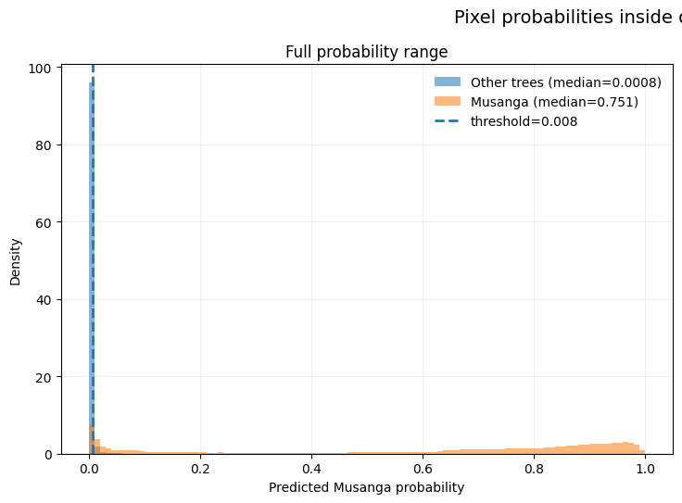
  Metric | Musanga | Other trees
  Number of evaluated pixels | 9,251,646 | 11,521,136
  Mean predicted probability | 0.606 | 0.003
  Median predicted probability | 0.751 | 0.001
  95th percentile probability | 0.974 | 0.007
  Fraction above threshold (0.008) | 93.5% | 4.4%

Example
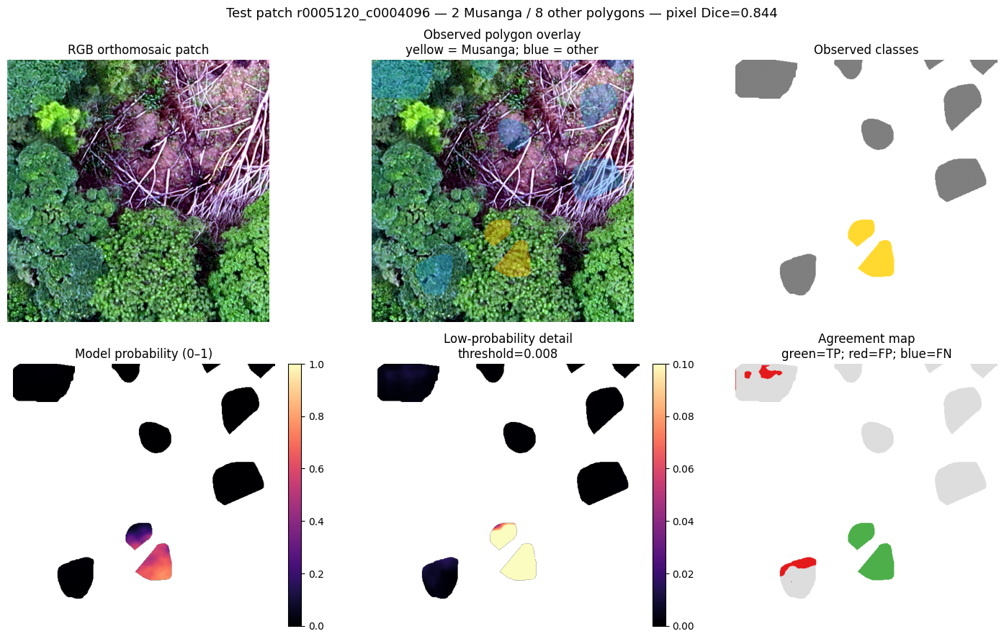

Summary Performance
The final model demonstrated excellent performance at the pixel level on an independent test dataset comprising more than 20.7 million labelled pixels. Using a validation-derived threshold of 0.008, the model achieved a precision of 94.4%, a recall of 93.5%, a Dice/F1 score of 0.94, and a ROC-AUC of 0.98, indicating near-perfect discrimination between Musanga and non-Musanga pixels. Performance at the polygon (tree crown) level was lower, but remained strong, with a precision of 81.6%, a recall of 80.7%, and a balanced accuracy of 81.0% across 488 independent tree crowns. The lower polygon-level performance reflects the greater difficulty of correctly classifying entire crowns, particularly in cases of mixed species composition, crown delineation uncertainty, or partial detection. Overall, the results demonstrate that the proposed U-Net approach provides highly reliable pixel-level Musanga mapping while maintaining good crown-level classification accuracy.

Metric | Pixel level | Polygon level
Evaluation units | 20,772,782 pixels | 488 tree crowns
Threshold | 0.008 | 0.004
Precision | 0.944 | 0.816
Recall | 0.935 | 0.807
Specificity | 0.956 | 0.813
Dice/F1 | 0.940 | 0.811
IoU | 0.886 | 0.683
Balanced accuracy | 0.946 | 0.810
ROC-AUC | 0.980 | 0.892
Average precision | 0.983 | 0.923
So, the model is exceptionally good at identifying Musanga pixels and remains robust when evaluated at the more challenging individual tree-crown level. An IoU of 0.89 and F1 of 0.94 on a very large held-out test sampl is strong!

Model Inference on whole ortho-mosaic
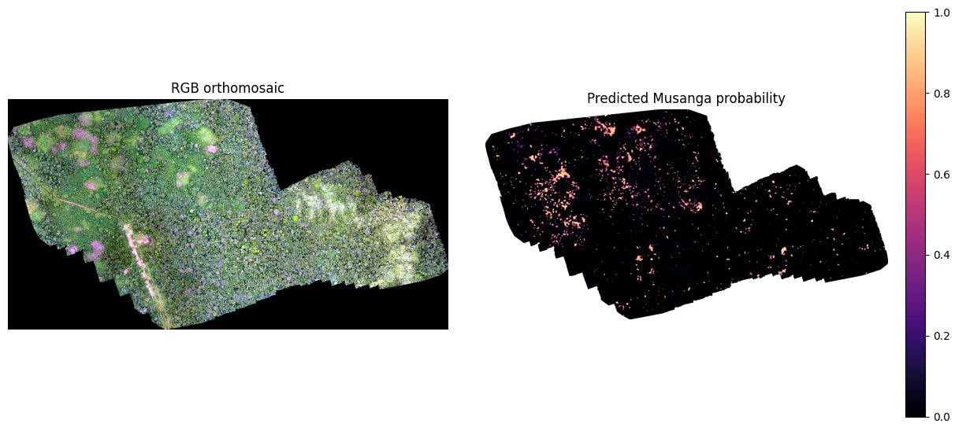
A detail (yellow is Nadine’s identification):
